SOCIAL MEDIA TOOLKIT: GPSA’S 8TH ANNUAL GLOBAL PARTNERS FORUM

GPSA’s social media
Contact
Grace Sinaga | gsinaga@worldbank.org
Marine Perron | mperron@worldbank.org
Maria Silva Morote | msilvamorote@worldbank.org
Social media name/tag
Twitter | @GPSA_org

Platform | Text | Visual asset
Pre-Forum
Twitter  05/14/2022  (PUBLISHED) | We are pleased to announce that the registration is open for the 8th GPSA Global Partners Forum – The GPSA at Ten: How Can Social Accountability Rise to Today’s Challenges? Happening on June 8 and 9, 2022.  Register today! Click here: bit.ly/3I9PiHa | 
Twitter  05/17/2022  (PUBLISHED) | COP26 chief @AlokSharma_RDG says leaders must do more to honor climate promises (link).  REGISTER NOW to join the GPSA’s 2022 where we will put the spotlight on the relevance of social accountability to today’s challenges.  Link: bit.ly/3I9PiHa | Image from news article
Twitter  05/20/2022  (PUBLISHED) | Tunisia’s Educational System Faces Many Challenges (link).  GPSA 2022 Forum: 8-9, 2022  Register today to discuss the learning crisis and its solutions through a social accountability lens.  Click here: bit.ly/3I9PiHa | Image from news article
Twitter  05/24/2022 | On June 8-9, 2022, GPSA will host its 8th Annual Global Partners Forum. The Forum brings together multiple actors to share knowledge, explore opportunities and emerging frontiers, and build the social accountability field. Register now! https://bit.ly/3l9PiHa | 
Twitter  05/26/2022 | SAVE THE DATE  🎬 The GPSA at Ten: How Can Social Accountability Rise to Today’s Challenges?  🗓️ 8-9 June 2022  🔗 bit.ly/3l9PiHa  💬 #GPSA2022Forum @GPSA_org | 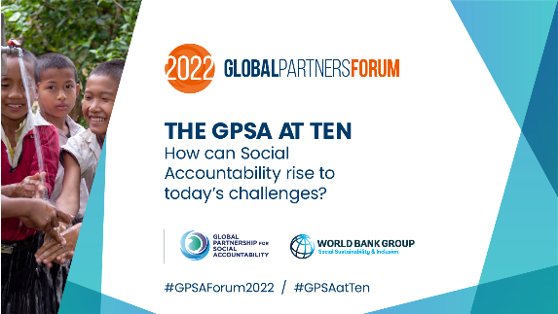
Twitter  06/02/2022 | At #GPSA2022Forum, you can:  ✔️ Reflect on social accountability in key development frontiers  ✔️ Discuss lessons from collaborative social accountability practice  ✔️ Explore how social accountability approaches can achieve scale  Register today! bit.ly/3l9PiHa #GPSA2022Forum
Twitter  06/05/2022 | How can #SocialAccountability rise to today’s challenges?  On June 8-9, join us for @GPSA_org’s 8th Annual Global Partners Forum to find out the answer!  Register today: bit.ly/3l9PiHa #GPSA2022Forum
Twitter  06/06/2022 | Stronger public health systems and citizen voice are critical to fight Covid-19. (Link)  Join our conversations on the intersection between COVID-19, civil society and social accountability on June 8th, 2022. Register today! bit.ly/3l9PiHa | Image from article
Twitter  06/07/2022 | Last day to register!  The #GPSAForum2022 will bring diverse voices to put a spotlight on the role and relevance of collaborative social accountability to today’s context.  Join the conversation TOMORROW! bit.ly/3l9PiHa #GPSA2022Forum @GPSA_org | 
Day 1
Twitter/Instagram | 🎬 The GPSA at Ten: How Can Social Accountability Rise to Today’s Challenges?  🗓️ 8 June 2022 | 🕔8:00 AM (ET)  🔗 https://bit.ly/3l9PiHa  💬 #GPSAForum2022 #GPSA2022Forum @GPSA_org
Facebook/LinkedIn |  | FACEBOOK 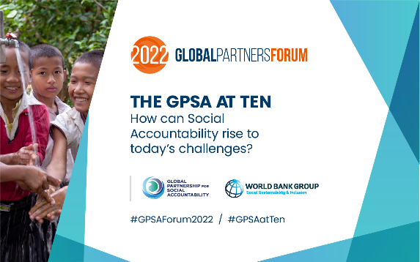LINKEDIN  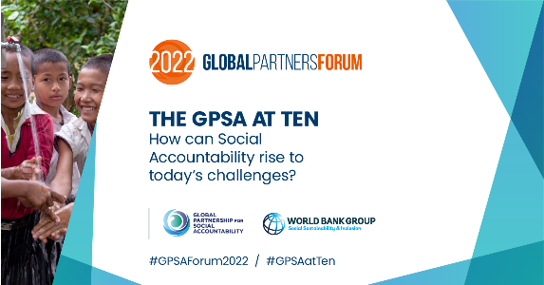
Day 2
Twitter/Instagram | 🎬 The GPSA at Ten: How Can Social Accountability Rise to Today’s Challenges?  🗓️ 9 June 2022 | 🕔8:00 AM (ET)  🔗 https://bit.ly/3l9PiHa  💬 #GPSAForum2022 #GPSA2022Forum @GPSA_org
Facebook/LinkedIn |  | FACEBOOK LINKEDIN

